Lecture by Primrose Wilson CBE
The Irish Landmark Trust
The Old Museum Building
Thursday 26th February
6.30 pm – 8. pm
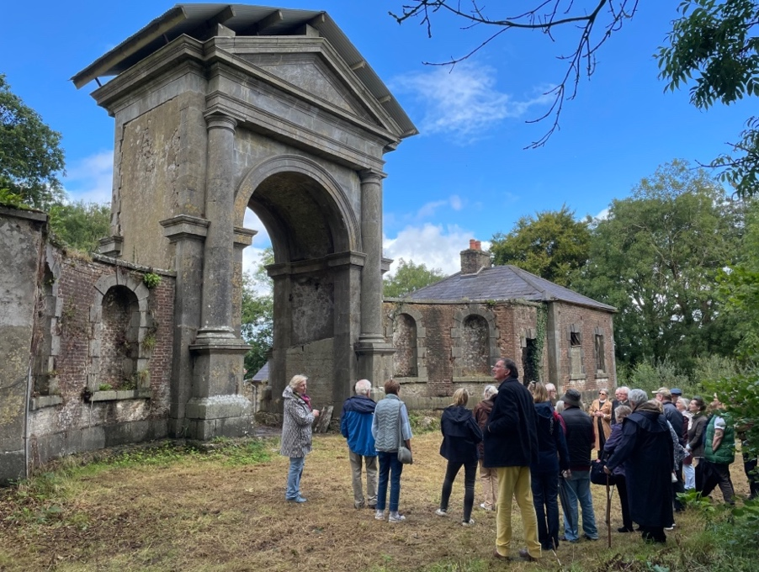
Saunderscourt arch and gate lodges
The Irish Landmark Trust (ILT) is celebrating its 30th anniversary. During that time, it has saved over 30 buildings across the island of Ireland and made them available for everyone to enjoy for very special holidays. Have you ever fancied staying in the Barbican gate lodge, Glenarm, or Blackhead lighthouse? Well thanks to the Irish Landmark Trust you can!

Primrose Wilson is a Trustee of the Irish Landmark Trust and in her illustrated talk will outline its work over the past 30 years and discuss its current project, the restoration of the Saunderscourt arch and gate lodges in County Wexford. This is one of the Trust’s most ambitious projects to date. Built c.1760, this rare surviving example of a form of Palladian architecture using curved links to a central archway will be a spectacular place to stay when completed.

Over many years, Primrose Wilson has worked tirelessly to promote and conserve architectural heritage. She has a long association with Ulster Architectural Heritage, serving previously as the Society’s Chair and President.
Members: £12 Non-members: £15 Students: £6
Light refreshments will be served from 6.30 pm.
Lecture to start promptly at 7 pm.
The Old Museum Building, 7 College Square North, Belfast BT1 6AR
Please note that due to the historic nature of The Old Museum Building, access is via a flight of stone steps. We regret that it is currently unsuitable for wheelchair users.

