Railway Stations of Berkeley Deane Wise
Wednesday 24th September 2025
10 am – 5 or 6 pm (approx)

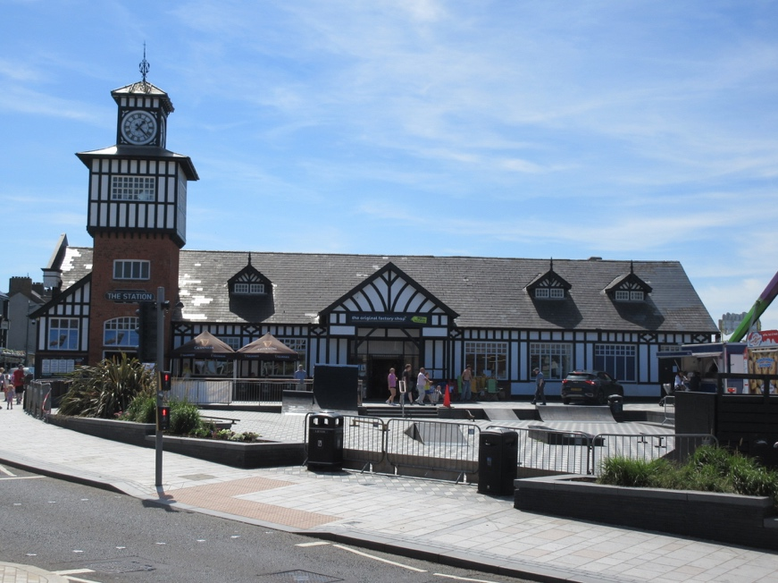
Portrush Station (2025)

Berkeley Deane Wise was Engineer of the Belfast and Northern Counties Railway and its successor the Northern Counties Committee of the Midland Railway from 1888 to 1906. Like many railway civil engineers of his era, he was responsible not only for the track, bridges, signalling etc but also for the design of stations. Unlike some of his contemporaries who tended to produce standard station designs that could be expanded or adapted to suit various sites, Wise’s designs were all different, often in a mock-Tudor cottage idiom but always tailored to the distinctive characteristics of their location. They are unlike the work of any other Irish railway architect.

The day will start and finish at Grand Central Station, Belfast, and will comprise a leisurely journey by service train through County Antrim, alighting at three of his best surviving stations – Antrim, Carrickfergus and his masterpiece – Portrush - to be given a more detailed introduction to his designs.

Members: £15 Non-Members: £20

- Tickets are available via Eventbrite on the UAH website and must be purchased in advance.

- Rail fares not included – SmartPass holders will be able to travel free of charge.

- Meals are not included, however there will be ample time on the trains to enjoy a picnic or have the option of an extra hour in Portrush to patronise one of the many cafes, restaurants and bars within easy walking distance of the station.

- Please wear sensible walking shoes and bring a raincoat in case of wet weather.

- Further details will be emailed to attendees approximately one week before the event.

