Lecture by Peter Fox

The Earl Bishop’s Building Ventures in the North of Ireland

Thursday 8th May 2025

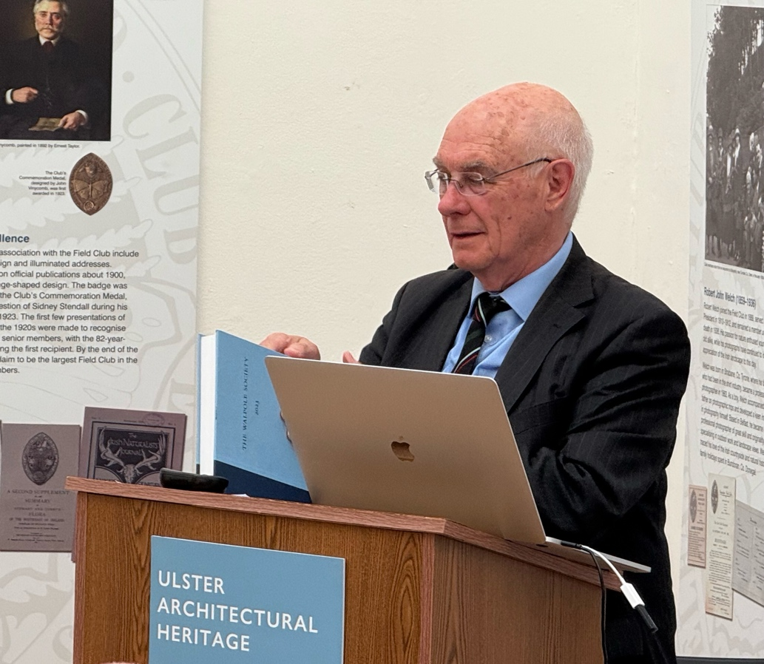

Peter Fox

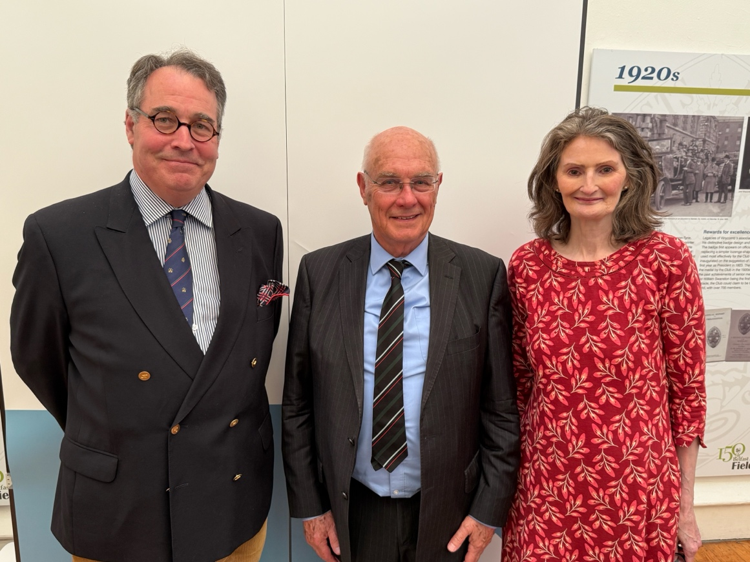

Dan Calley, Chair of UAH, Peter Fox, Speaker, Susan Hannam, Chair of Events

On Thursday 8th May, Peter Fox, former Librarian of Cambridge University, gave a most enjoyable and insightful lecture on the building ventures in Ireland of the 4th Earl of Bristol. Drawing upon his detailed research on the Earl Bishop’s correspondence and using a beautiful selection of slides, Peter explained the fascinating, though often strained, dynamic between the fickle-minded earl and his architects. He also showed us the very detailed designs for many of the Earl Bishop’s buildings, including the great houses of Downhill and Ballyscullion.

Many thanks to Peter for such an excellent lecture.

